**Principles of Compiler**

**Construction**

(CDCSC14)



PRACTICAL FILE

SUBMITTED BY,

KARANPREET SINGH

2020UCD2111

**INDEX**

|  |  |  |
| --- | --- | --- |
| **PRACTICAL NO.** | **PRACTICAL** | **PG NO.** |
| 1 | Implement Symbol Table in C/C++ | 3 |
| 2 | Write a program to parse an input string as a lexical analyser | 8 |
| 3 | Write a program to remove left recursion from a context-free grammar | 10 |
| 4 | Write a program to find the first and follow | 12 |
| 5 | Write a program to implement predictive parsing | 16 |
| 6 | Write a program to check whether the given grammar is LR (0) or not | 21 |
| 7 | Write a Lex program to recognize keywords and identifiers in the input "C" program | 26 |
| 8 | Write a parser for a simple calculator using the LEX and YACC tools | 28 |
| 9 | Implement a two-pass assembler | 32 |
| 10 | Write a C program to generate a three address code for a given expression | 38 |

**PRACTICAL-1**

**Aim-** Implement Symbol Table in C/C++.

**Code-**

#include <bits/stdc++.h>

using namespace std;

class Node

{

public:

string identifier, scope, type;

int lineNo;

Node *next;

Node(string identifier, string scope, string type, int lineNo)

{

this->identifier = identifier;

this->scope = scope;

this->type = type;

this->lineNo = lineNo;

}

~Node()

{

if (next != NULL)

{

delete next;

}

}

void print()

{

cout << "Identifier's Name:" << identifier

<< "\nType:" << type

<< "\nScope: " << scope

<< "\nLine Number: " << lineNo << endl;

}

};

class SymbolTable

{

Node **table;

int table_size;

int hashFn(string key)

{

int index = 0;

int p = 1;

for (int i = 0; i < key.length(); i++)

{

index = index + (key[i] * p) % table_size;

index = index % table_size;

p = (p * 27) % table_size;

}

return index;

}

public:

SymbolTable(int size = 7)

{

table_size = size;

table = new Node *[table_size];

for (int i = 0; i < table_size; i++)

{

table[i] = NULL;

}

}

void insert(string id, string scope, string type, int lineno)

{

int index = hashFn(id);

Node *n = new Node(id, scope, type, lineno);

n->next = table[index];

table[index] = n;

}

Node *find(string key)

{

int index = hashFn(key);

Node *ptr = table[index];

while (ptr != NULL)

{

if (ptr->identifier == key)

{

return ptr;

}

ptr = ptr->next;

}

return NULL;

}

bool erase(string key)

{

int index = hashFn(key);

Node *ptr = table[index];

if (ptr != NULL)

{

if (ptr->identifier == key)

{

table[index] = ptr->next;

return true;

}

Node *prev = ptr;

ptr = ptr->next;

while (ptr != NULL)

{

if (ptr->identifier == key)

{

prev->next = ptr->next;

ptr->next = NULL;

delete ptr;

return true;

}

prev = ptr;

ptr = ptr->next;

}

}

return false;

}

Node *modify(string id, string scope, string type, int lineno)

{

int index = hashFn(id);

Node *ptr = table[index];

while (ptr != NULL)

{

if (ptr->identifier == id)

{

ptr->scope = scope;

ptr->type = type;

ptr->lineNo = lineno;

return ptr;

}

ptr = ptr->next;

}

return NULL;

}

void print()

{

for (int i = 0; i < table_size; i++)

{

cout << "Bucket " << i << " ->";

Node *ptr = table[i];

while (ptr != NULL)

{

cout << ptr->identifier << "->";

ptr = ptr->next;

}

cout << endl;

}

}

};

int main()

{

SymbolTable s;

s.insert("if", "local", "keyword", 4);

s.insert("number", "global", "variable", 2);

s.insert("add", "global", "function", 1);

s.insert("sum", "local", "int", 3);

s.insert("a", "function parameter", "int", 1);

Node *ptr = s.find("if");

if (ptr != NULL)

{

cout << "if Identifier is present\n";

ptr->print();

}

else

{

cout << "if Identifier not present\n";

}

if (s.erase("if") == true)

{

cout << "\nif Identifier is deleted\n";

}

else

{

cout << "\nFailed to delete if identifier\n";

}

ptr = s.modify("if", "global", "variable", 3);

if (ptr != NULL)

{

cout << "\nif Identifier updated\n";

ptr->print();

}

else

{

cout << "\nFailed to update if identifer\n";

}

ptr = s.find("if");

if (ptr != NULL)

{

cout << "\nif Identifier is present\n";

ptr->print();

}

else

{

cout << "\nif Identifier not present\n";

}

ptr = s.modify("number", "global", "variable", 3);

if (ptr != NULL)

{

cout << "\nnumber Identifier updated\n";

ptr->print();

}

else

{

cout << "\nFailed to update number identifer\n";

}

ptr = s.find("number");

if (ptr != NULL)

{

cout << "\nnumber Identifier is present\n";

ptr->print();

}

else

{

cout << "\nnumber Identifier not present\n";

}

cout << "\n**** SYMBOL_TABLE ****\n";

s.print();

return 0;

}

**OUTPUT-**

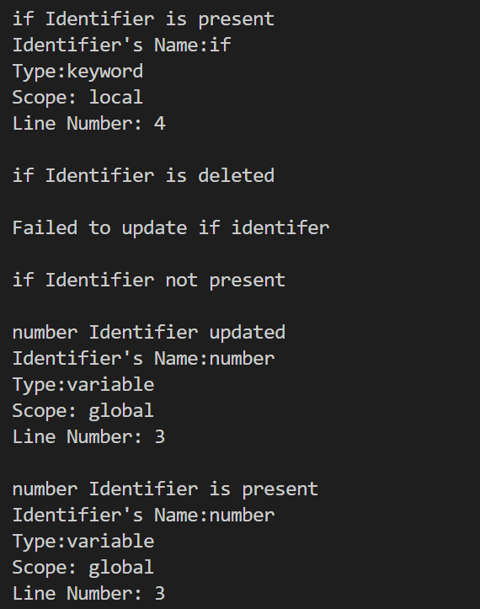

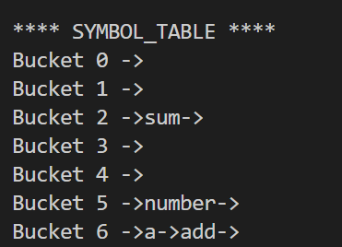

**PRACTICAL-2**

**Aim-** Write a program to parse an input string as a lexical analyser.

**Description-** The lexical analyzer takes an input string and count the number of

words.

**Code-**

/*lex program to count number of words*/

%{

#include<stdio.h>

#include<string.h>

int i = 0;

%}

/* Rules Section*/

%%

([a-zA-Z0-9])* {i++;} /* Rule for counting

number of words*/

"\n" {printf("%d\n", i); i = 0;}

%%

int yywrap(void){}

int main()

{

// The function that starts the analysis

yylex();

return 0;

}

**OUTPUT-**

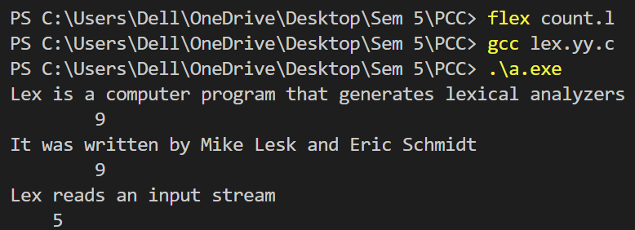

**PRACTICAL-3**

**Aim-** Write a program to remove left recursion from a context-free grammar.

**Code-**

#include <iostream>

#include <string.h>

#define SIZE 10

using namespace std;

int main()

{

char non_terminal;

char beta, alpha;

int num;

char production[10][SIZE];

int index = 3;

cout << "Enter the number of productions : ";

cin >> num;

cout << "Enter the grammar as E->E-A|B : \n";

for (int i = 0; i < num; i++)

{

cin >> production[i];

}

for (int i = 0; i < num; i++)

{

cout << "\nGRAMMAR : : : " << production[i];

non_terminal = production[i][0];

if (non_terminal == production[i][index])

{

alpha = production[i][index + 1];

cout << " is left recursive.\n";

while (production[i][index] != 0 && production[i][index] != '|')

{

index++;

}

if (production[i][index] != 0)

{

beta = production[i][index + 1];

cout << "Grammar without left recursion:\n";

cout << non_terminal << "->" << beta << non_terminal << "\'";

cout << "\n"

<< non_terminal << "\'->" << alpha << non_terminal << "\'|E\n";

}

else

{

cout << " can't be reduced\n";

}

}

else

{

cout << " is not left recursive.\n";

}

index = 3;

}

return 0;

}

**OUTPUT-**

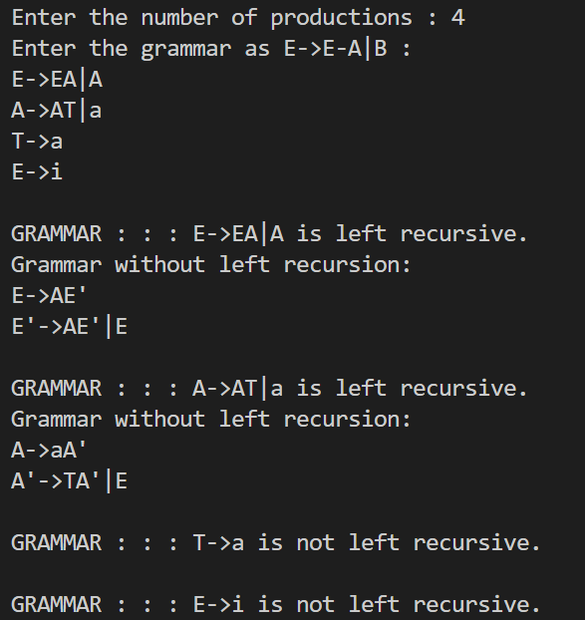

**PRACTICAL-4**

**Aim-** Write a program to find the first and follow.

**Code-**

#include <iostream>

#include <string.h>

#define max 20

using namespace std;

char prod[max][10];

char ter[10], nt[10];

char first[10][10], follow[10][10];

int eps[10];

int count = 0;

int findpos(char ch)

{

int n;

for (n = 0; nt[n] != '\0'; n++)

{

if (nt[n] == ch)

break;

}

if (nt[n] == '\0')

return 1;

return n;

}

int IsCap(char c)

{

if (c >= 'A' && c <= 'Z')

return 1;

return 0;

}

void add(char *arr, char c)

{

int i, flag = 0;

for (i = 0; arr[i] != '\0'; i++)

{

if (arr[i] == c)

{

flag = 1;

break;

}

}

if (flag != 1)

arr[strlen(arr)] = c;

}

void addarr(char *s1, char *s2)

{

int i, j, flag = 99;

for (i = 0; s2[i] != '\0'; i++)

{

flag = 0;

for (j = 0;; j++)

{

if (s2[i] == s1[j])

{

flag = 1;

break;

}

if (j == strlen(s1) && flag != 1)

{

s1[strlen(s1)] = s2[i];

break;

}

}

}

}

void addprod(char *s)

{

int i;

prod[count][0] = s[0];

for (i = 3; s[i] != '\0'; i++)

{

if (!IsCap(s[i]))

add(ter, s[i]);

prod[count][i - 2] = s[i];

}

prod[count][i - 2] = '\0';

add(nt, s[0]);

count++;

}

void findfirst()

{

int i, j, n, k, e, n1;

for (i = 0; i < count; i++)

{

for (j = 0; j < count; j++)

{

n = findpos(prod[j][0]);

if (prod[j][1] == (char)238)

eps[n] = 1;

else

{

for (k = 1, e = 1; prod[j][k] != '\0' && e == 1; k++)

{

if (!IsCap(prod[j][k]))

{

e = 0;

add(first[n], prod[j][k]);

}

else

{

n1 = findpos(prod[j][k]);

addarr(first[n], first[n1]);

if (eps[n1] == 0)

e = 0;

}

}

if (e == 1)

eps[n] = 1;

}

}

}

}

void findfollow()

{

int i, j, k, n, e, n1;

n = findpos(prod[0][0]);

add(follow[n], '#');

for (i = 0; i < count; i++)

{

for (j = 0; j < count; j++)

{

k = strlen(prod[j]) - 1;

for (; k > 0; k--)

{

if (IsCap(prod[j][k]))

{

n = findpos(prod[j][k]);

if (prod[j][k + 1] == '\0')

{

n1 = findpos(prod[j][0]);

addarr(follow[n], follow[n1]);

}

if (IsCap(prod[j][k + 1]))

{

n1 = findpos(prod[j][k + 1]);

addarr(follow[n], first[n1]);

if (eps[n1] == 1)

{

n1 = findpos(prod[j][0]);

addarr(follow[n], follow[n1]);

}

}

else if (prod[j][k + 1] != '\0')

add(follow[n], prod[j][k + 1]);

}

}

}

}

}

int main()

{

char s[max], i;

cout << "Enter the productions(type 'end' at the last of the production)-\n";

cin >> s;

while (strcmp("end", s))

{

addprod(s);

cin >> s;

}

findfirst();

findfollow();

cout << "\tFIRST\tFOLLOW\n";

for (i = 0; i < strlen(nt); i++)

{

cout << nt[i] << "\t";

cout << first[i];

if (eps[i] == 1)

cout << ((char)238) << "\t";

else

cout << "\t";

cout << follow[i] << "\n";

}

return 0;

}

**OUTPUT-**

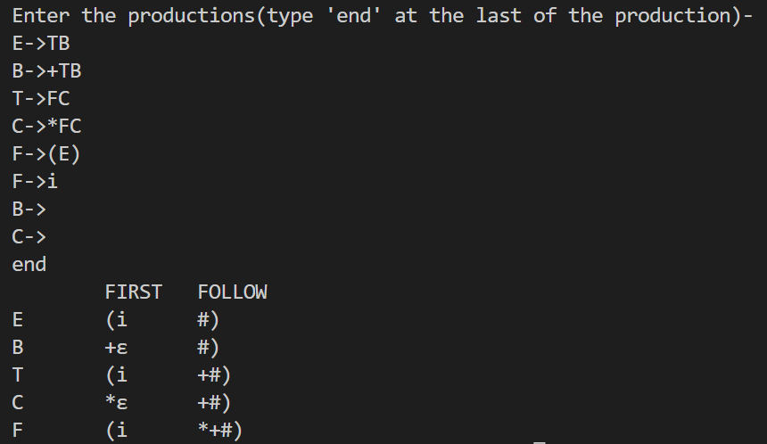

**PRACTICAL-5**

**Aim-** Write a program to implement predictive parsing.

**Code-**

#include <iostream>

#include <string.h>

using namespace std;

int main()

{

char fin[10][20], st[10][20], ft[20][20], fol[20][20];

int a = 0, e, i, t, b, c, n, k, l = 0, j, s, m, p;

cout << "Enter the no. of non-terminals : ";

cin >> n;

cout << "\nEnter the productions (E->Ea|B) : \n";

for (i = 0; i < n; i++)

cin >> st[i];

for (i = 0; i < n; i++)

fol[i][0] = '\0';

for (s = 0; s < n; s++)

{

for (i = 0; i < n; i++)

{

j = 3;

l = 0;

a = 0;

l1:

if (!((st[i][j] > 64) && (st[i][j] < 91)))

{

for (m = 0; m < l; m++)

{

if (ft[i][m] == st[i][j])

goto s1;

}

ft[i][l] = st[i][j];

l = l + 1;

s1:

j = j + 1;

}

else

{

if (s > 0)

{

while (st[i][j] != st[a][0])

{

a++;

}

b = 0;

while (ft[a][b] != '\0')

{

for (m = 0; m < l; m++)

{

if (ft[i][m] == ft[a][b])

goto s2;

}

ft[i][l] = ft[a][b];

l = l + 1;

s2:

b = b + 1;

}

}

}

while (st[i][j] != '\0')

{

if (st[i][j] == '|')

{

j = j + 1;

goto l1;

}

j = j + 1;

}

ft[i][l] = '\0';

}

}

cout << "First of all the non-terminals : \n";

for (i = 0; i < n; i++)

cout << "FIRST[" << st[i][0] << "]=" << ft[i] << "\n";

fol[0][0] = '$';

for (i = 0; i < n; i++)

{

k = 0;

j = 3;

if (i == 0)

l = 1;

else

l = 0;

k1:

while ((st[i][0] != st[k][j]) && (k < n))

{

if (st[k][j] == '\0')

{

k++;

j = 2;

}

j++;

}

j = j + 1;

if (st[i][0] == st[k][j - 1])

{

if ((st[k][j] != '|') && (st[k][j] != '\0'))

{

a = 0;

if (!((st[k][j] > 64) && (st[k][j] < 91)))

{

for (m = 0; m < l; m++)

{

if (fol[i][m] == st[k][j])

goto q3;

}

fol[i][l] = st[k][j];

q3:

l++;

}

else

{

while (st[k][j] != st[a][0])

{

a++;

}

p = 0;

while (ft[a][p] != '\0')

{

if (ft[a][p] != '@')

{

for (m = 0; m < l; m++)

{

if (fol[i][m] == ft[a][p])

goto q2;

}

fol[i][l] = ft[a][p];

l = l + 1;

}

else

e = 1;

q2:

p++;

}

if (e == 1)

{

e = 0;

goto a1;

}

}

}

else

{

a1:

c = 0;

a = 0;

while (st[k][0] != st[a][0])

{

a++;

}

while ((fol[a][c] != '\0') && (st[a][0] != st[i][0]))

{

for (m = 0; m < l; m++)

{

if (fol[i][m] == fol[a][c])

goto q1;

}

fol[i][l] = fol[a][c];

l++;

q1:

c++;

}

}

goto k1;

}

fol[i][l] = '\0';

}

cout << "Follow of all the non-terminals : \n";

for (i = 0; i < n; i++)

cout << "FOLLOW[" << st[i][0] << "=" << fol[i] << "\n";

cout << "\n";

s = 0;

for (i = 0; i < n; i++)

{

j = 3;

while (st[i][j] != '\0')

{

if ((st[i][j - 1] == '|') || (j == 3))

{

for (p = 0; p <= 2; p++)

{

fin[s][p] = st[i][p];

}

t = j;

for (p = 3; ((st[i][j] != '|') && (st[i][j] != '\0')); p++)

{

fin[s][p] = st[i][j];

j++;

}

fin[s][p] = '\0';

if (st[i][k] == '@')

{

b = 0;

a = 0;

while (st[a][0] != st[i][0])

{

a++;

}

while (fol[a][b] != '\0')

{

cout << "TABLE[" << st[i][0] << "," << fol[a][b] << "]=" << fin[s] << "\n";

b++;

}

}

else if (!((st[i][t] > 64) && (st[i][t] < 91)))

cout << "TABLE[" << st[i][0] << "," << st[i][t] << "]=" << fin[s] << "\n";

else

{

b = 0;

a = 0;

while (st[a][0] != st[i][3])

a++;

while (ft[a][b] != '\0')

{

cout << "TABLE[" << st[i][0] << "," << ft[a][b] << "]=" << fin[s] << "\n";

b++;

}

}

s++;

}

if (st[i][j] == '|')

j++;

}

}

return 0;

}

**OUTPUT-**

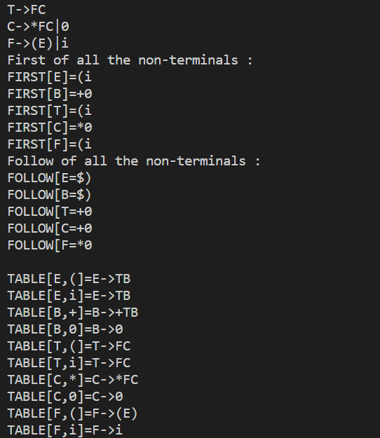

**PRACTICAL-6**

**Aim-** Write a program to check whether the given grammar is LR (0) or not.

**Code-**

#include <iostream>

#include <string.h>

using namespace std;

char prod[20][20], listofvar[26] = "ABCDEFGHIJKLMNOPQR";

int novar = 1, i = 0, j = 0, k = 0, n = 0, m = 0, arr[30];

int noitem = 0;

struct Grammar

{

char lhs;

char rhs[8];

} g[20], item[20], clos[20][10];

int isvariable(char variable)

{

for (int i = 0; i < novar; i++)

if (g[i].lhs == variable)

return i + 1;

return 0;

}

void findclosure(int z, char a)

{

int n = 0, i = 0, j = 0, k = 0, l = 0;

for (i = 0; i < arr[z]; i++)

{

for (j = 0; j < strlen(clos[z][i].rhs); j++)

{

if (clos[z][i].rhs[j] == '.' && clos[z][i].rhs[j + 1] == a)

{

clos[noitem][n].lhs = clos[z][i].lhs;

strcpy(clos[noitem][n].rhs, clos[z][i].rhs);

char temp = clos[noitem][n].rhs[j];

clos[noitem][n].rhs[j] = clos[noitem][n].rhs[j + 1];

clos[noitem][n].rhs[j + 1] = temp;

n = n + 1;

}

}

}

for (i = 0; i < n; i++)

{

for (j = 0; j < strlen(clos[noitem][i].rhs); j++)

{

if (clos[noitem][i].rhs[j] == '.' && isvariable(clos[noitem][i].rhs[j + 1]) > 0)

{

for (k = 0; k < novar; k++)

{

if (clos[noitem][i].rhs[j + 1] == clos[0][k].lhs)

{

for (l = 0; l < n; l++)

if (clos[noitem][l].lhs == clos[0][k].lhs &&

strcmp(clos[noitem][l].rhs, clos[0][k].rhs) == 0)

break;

if (l == n)

{

clos[noitem][n].lhs = clos[0][k].lhs;

strcpy(clos[noitem][n].rhs, clos[0][k].rhs);

n = n + 1;

}

}

}

}

}

}

arr[noitem] = n;

int flag = 0;

for (i = 0; i < noitem; i++)

{

if (arr[i] == n)

{

for (j = 0; j < arr[i]; j++)

{

int c = 0;

for (k = 0; k < arr[i]; k++)

if (clos[noitem][k].lhs == clos[i][k].lhs &&

strcmp(clos[noitem][k].rhs, clos[i][k].rhs) == 0)

c = c + 1;

if (c == arr[i])

{

flag = 1;

goto exit;

}

}

}

}

exit:;

if (flag == 0)

arr[noitem++] = n;

}

int main()

{

cout << "Enter all the productions (add 0 to end) : \n";

do

{

cin >> prod[i++];

} while (strcmp(prod[i - 1], "0") != 0);

for (n = 0; n < i - 1; n++)

{

m = 0;

j = novar;

g[novar++].lhs = prod[n][0];

for (k = 3; k < strlen(prod[n]); k++)

{

if (prod[n][k] != '|')

g[j].rhs[m++] = prod[n][k];

if (prod[n][k] == '|')

{

g[j].rhs[m] = '\0';

m = 0;

j = novar;

g[novar++].lhs = prod[n][0];

}

}

}

for (i = 0; i < 26; i++)

if (!isvariable(listofvar[i]))

break;

g[0].lhs = listofvar[i];

char temp[2] = {g[1].lhs, '\0'};

strcat(g[0].rhs, temp);

cout << "\n\n augumented grammar \n";

for (i = 0; i < novar; i++)

cout << endl

<< g[i].lhs << "->" << g[i].rhs << " ";

for (i = 0; i < novar; i++)

{

clos[noitem][i].lhs = g[i].lhs;

strcpy(clos[noitem][i].rhs, g[i].rhs);

if (strcmp(clos[noitem][i].rhs, "ε") == 0)

strcpy(clos[noitem][i].rhs, ".");

else

{

for (int j = strlen(clos[noitem][i].rhs) + 1; j >= 0; j--)

clos[noitem][i].rhs[j] = clos[noitem][i].rhs[j - 1];

clos[noitem][i].rhs[0] = '.';

}

}

arr[noitem++] = novar;

for (int z = 0; z < noitem; z++)

{

char list[10];

int l = 0;

for (j = 0; j < arr[z]; j++)

{

for (k = 0; k < strlen(clos[z][j].rhs) - 1; k++)

{

if (clos[z][j].rhs[k] == '.')

{

for (m = 0; m < l; m++)

if (list[m] == clos[z][j].rhs[k + 1])

break;

if (m == l)

list[l++] = clos[z][j].rhs[k + 1];

}

}

}

for (int x = 0; x < l; x++)

findclosure(z, list[x]);

}

cout << "\n THE SET OF ITEMS ARE \n\n";

for (int z = 0; z < noitem; z++)

{

cout << "\n I" << z << "\n\n";

for (j = 0; j < arr[z]; j++)

cout << clos[z][j].lhs << "->" << clos[z][j].rhs << "\n";

}

return 0;

}

**OUTPUT-**

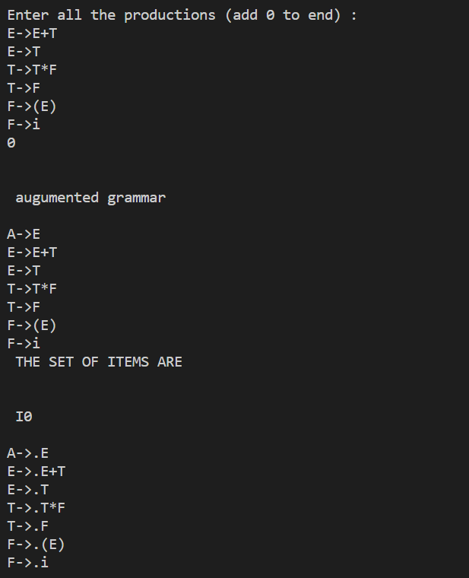

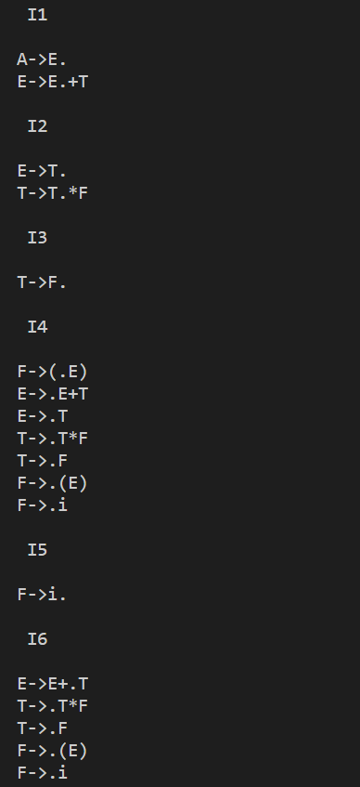 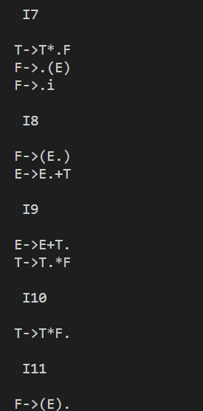

**PRACTICAL-7**

**Aim-** Write a Lex program to recognize keywords and identifiers in the input "C"

program.

**Code-**

%{

#include<stdio.h>

%}

digit [0-9]

letter [a-zA-z]

id {letter}({letter}|{digit})*

delim [ \t]

operator [+ = - * < > ; <= >= ==]

%%

{digit}+ {printf("num: %s\n" , yytext);}

{id} {printf("ident: %s\n" , yytext);}

{delim} {printf("delim: %s\n" , yytext);}

{operator} {printf("op: %s\n" , yytext);}

. {printf("other: %s\n", yytext);}

%%

int yywrap()

{

return(1);

}

void main()

{

yylex();

}

**OUTPUT-**

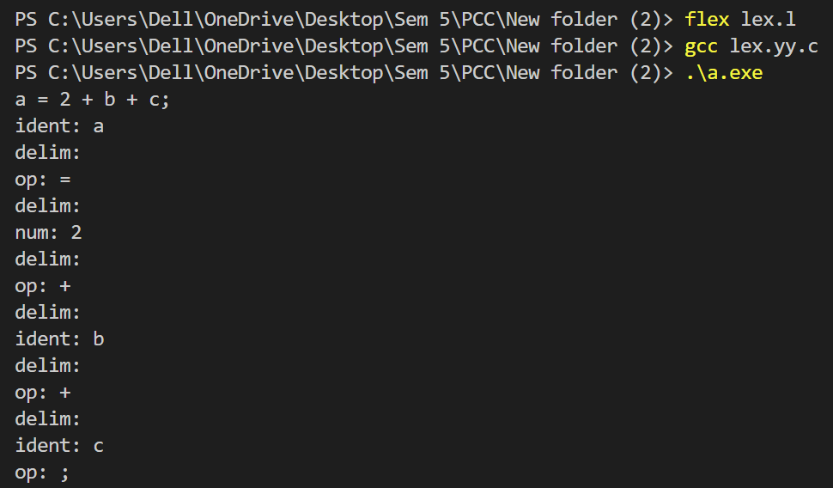

**PRACTICAL-8**

**Aim-** Write a parser for a simple calculator using the LEX and YACC tools.

**Code-**

**Lexical Analyzer Source Code:**

%{

/* Definition section */

#include<stdio.h>

#include "y.tab.h"

extern int yylval;

%}

/* Rule Section */

%%

[0-9]+ {

yylval=atoi(yytext);

return NUMBER;

}

[\t] ;

[\n] return 0;

. return yytext[0];

%%

int yywrap()

{

return 1;

}

**Parser Source Code:**

%{

/* Definition section */

#include<stdio.h>

int flag=0;

%}

%token NUMBER

%left '+' '-'

%left '*' '/' '%'

%left '(' ')'

/* Rule Section */

%%

ArithmeticExpression: E{

printf("\nResult=%d\n", $$);

return 0;

};

E:E'+'E {$$=$1+$3;}

|E'-'E {$$=$1-$3;}

|E'*'E {$$=$1*$3;}

|E'/'E {$$=$1/$3;}

|E'%'E {$$=$1%$3;}

|'('E')' {$$=$2;}

| NUMBER {$$=$1;}

;

%%

//driver code

void main()

{

printf("\nEnter Any Arithmetic Expression which can have operations Addition, Subtraction, Multiplication, Division, Modulus and Round brackets:\n");

yyparse();

if(flag==0)

printf("\nEntered arithmetic expression is Valid\n\n");

}

void yyerror()

{

printf("\nEntered arithmetic expression is Invalid\n\n");

flag=1;

}

**OUTPUT-**

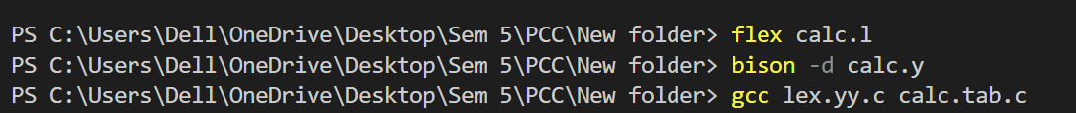

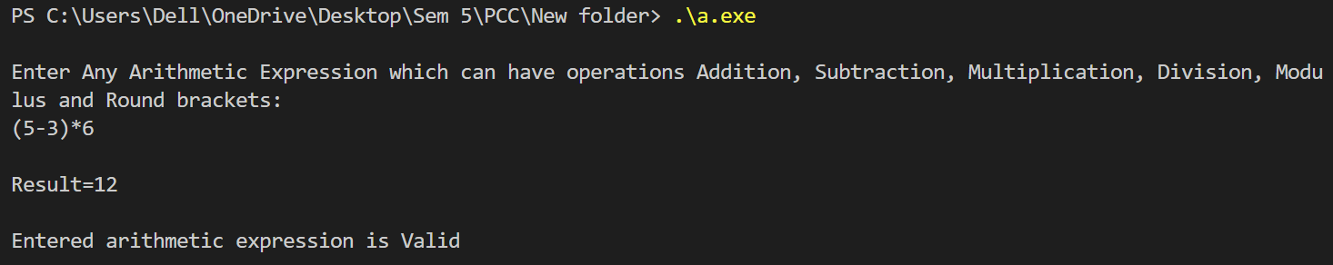

**PRACTICAL-9**

**Aim-** Implement a two-pass assembler.

**Code-**

**two_pass_assembler.cpp**

#include <bits/stdc++.h>

using namespace std;

/*

Supported instructions:

ORG

JMP

MOV

ADD

AND

HLT

*/

void mov_hex_value(vector<int> &reg, int start, int len, int val)

{

for (int i = start; i < start + len; i++)

{

reg[i] = val % 16;

val = val / 16;

}

}

void add_hex_value(vector<int> &reg, int start, int len, vector<int> &reg2, int start2, int len2)

{

if (len != len2)

{

cout << "Error" << endl;

return;

}

int carry = 0;

for (int i = start, j = start2; i < start + len, j < start2 + len2; i++, j++)

{

int val = carry + reg[i] + reg2[j];

reg[i] = val % 16;

carry = val / 16;

}

}

void and_hex_value(vector<int> &reg, int start, int len, int val)

{

for (int i = start; i < start + len; i++)

{

reg[i] = (reg[i] & val) % 16;

val = val / 16;

}

}

void show_reg(vector<int> &reg)

{

for (int i = reg.size() - 1; i >= 0; i--)

{

char ch = 'A' + (reg[i] - 10);

if (reg[i] <= 9)

cout << reg[i];

else

cout << ch;

}

cout << endl;

}

int main()

{

unordered_map<string, int> symbolTable;

unordered_map<string, string> opCode;

opCode["JMP"] = "EA", opCode["MOV"] = "B0", opCode["ADD"] = "04";

opCode["AND"] = "84", opCode["HLT"] = "F4";

vector<vector<int>> reg(4, vector<int>(4, 0)); // registers

int starting_address = 0;

int lines = 0;

ifstream rdfil;

rdfil.open("input.asm");

string line;

// Pass 1

while (rdfil >> line)

{

if (line == "ORG")

{

rdfil >> line;

starting_address = stoi(line);

}

else if (line == "HLT")

{

lines++;

continue;

}

else if (line == "JMP")

{

rdfil >> line;

if (symbolTable.find(line) == symbolTable.end())

symbolTable[line] = -1;

}

else if (line == "MOV" or line == "ADD" or line == "AND")

{

rdfil >> line;

rdfil >> line;

}

else

{

line.pop_back(); // omitting colon

symbolTable[line] = starting_address + lines;

}

lines++;

}

cout << "The Symbol Table after Pass 1: " << endl;

cout << "Label"

<< "\t"

<< "Address" << endl;

for (auto i = symbolTable.begin(); i != symbolTable.end(); i++)

cout << i->first << "\t" << i->second << endl;

cout << endl;

rdfil.close();

rdfil.open("input.asm");

ofstream wtfil("output.txt");

lines = 0;

// Pass 2

while (rdfil >> line)

{

wtfil << starting_address + lines << " ";

if (line == "ORG")

{

wtfil << "ORG ";

rdfil >> line;

wtfil << line << endl;

}

else if (line == "MOV" or line == "ADD" or line == "AND")

{

string instruction = line;

wtfil << opCode[line] << " ";

rdfil >> line;

wtfil << line << " ";

line.pop_back(); // drop comma

string reg_name = line;

rdfil >> line;

wtfil << line << endl;

int reg_no = reg_name[0] - 'A';

int len = (reg_name[1] == 'X' ? 4 : 2);

int start = (reg_name[1] == 'H' ? 2 : 0);

int literal;

if (instruction != "ADD")

literal = stoi(line);

if (instruction == "MOV")

mov_hex_value(reg[reg_no], start, len, literal);

else if (instruction == "AND")

and_hex_value(reg[reg_no], start, len, literal);

else

{

int reg2_no = line[0] - 'A';

int len2 = (line[1] == 'X' ? 4 : 2);

int start2 = (line[1] == 'H' ? 2 : 0);

add_hex_value(reg[reg_no], start, len, reg[reg2_no], start2, len2);

}

}

else if (line == "JMP")

{

wtfil << opCode[line] << " ";

rdfil >> line;

string label = line;

wtfil << symbolTable[label] << endl;

int line_no = symbolTable[label] - starting_address;

rdfil.close();

rdfil.open("input.asm");

int ct = 0;

while (line_no != ct && getline(rdfil, line))

ct++;

rdfil >> line;

}

else if (line == "HLT")

{

wtfil << opCode[line];

break;

}

else

wtfil << endl;

lines++;

}

cout << "Output of Pass 2 has been written in output.txt !!!" << endl

<< endl;

cout << "Here is the value of registers after the program" << endl;

for (int i = 0; i < 4; i++)

{

string str = "";

str += (char)('A' + i);

str += "X";

cout << str << " ";

show_reg(reg[i]);

}

rdfil.close();

wtfil.close();

return 0;

}

**input.asm**

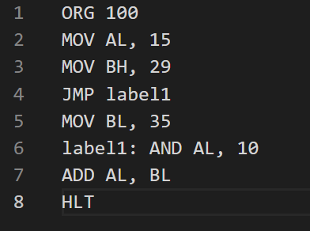

**OUTPUT-**

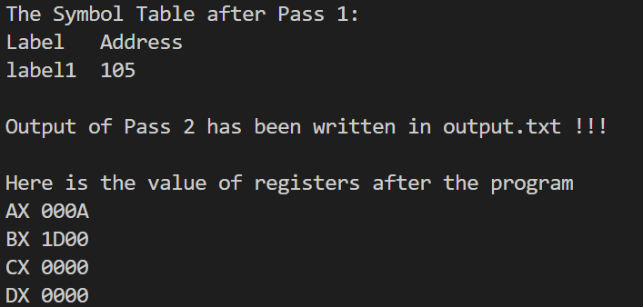

**output.txt**

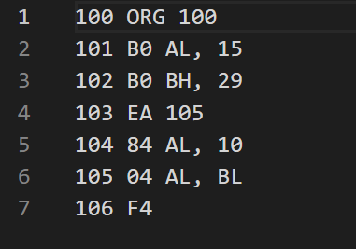

**PRACTICAL-10**

**Aim-** Write a C program to generate a three address code for a given expression.

**Code-**

#include <iostream>

#include <stdlib.h>

#include <string.h>

using namespace std;

struct three

{

char data[10], temp[7];

} s[30];

int main()

{

char d1[7], d2[7] = "t";

int i = 0, j = 1, len = 0;

FILE *f1, *f2;

f1 = fopen("sum.txt", "r");

f2 = fopen("out.txt", "w");

while (fscanf(f1, "%s", s[len].data) != EOF)

len++;

itoa(j, d1, 7);

strcat(d2, d1);

strcpy(s[j].temp, d2);

strcpy(d1, "");

strcpy(d2, "t");

if (!strcmp(s[3].data, "+"))

{

fprintf(f2, "%s=%s+%s", s[j].temp, s[i + 2].data, s[i + 4].data);

j++;

}

else if (!strcmp(s[3].data, "-"))

{

fprintf(f2, "%s=%s-%s", s[j].temp, s[i + 2].data, s[i + 4].data);

j++;

}

for (i = 4; i < len - 2; i += 2)

{

itoa(j, d1, 7);

strcat(d2, d1);

strcpy(s[j].temp, d2);

if (!strcmp(s[i + 1].data, "+"))

fprintf(f2, "\n%s=%s+%s", s[j].temp, s[j - 1].temp, s[i + 2].data);

else if (!strcmp(s[i + 1].data, "-"))

fprintf(f2, "\n%s=%s-%s", s[j].temp, s[j - 1].temp, s[i + 2].data);

strcpy(d1, "");

strcpy(d2, "t");

j++;

}

fprintf(f2, "\n%s=%s", s[0].data, s[j - 1].temp);

fclose(f1);

fclose(f2);

return 0;

}

**sum.txt**

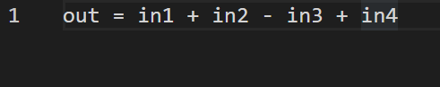

**out.txt**

